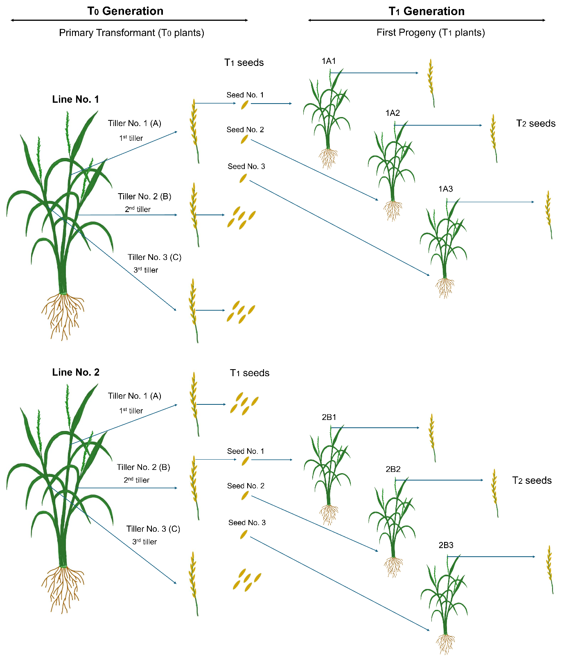
Supplementary Figure 1: The schematic of the primary transgenic rice line was harvested and tested in the following generations

