Plant Breed. Biotech. 2018 (June) 6(2):125~139  https://doi.org/10.9787/PBB.2018.6.2.125 | Online ISSN: 2287-9366  Print ISSN: 2287-9358

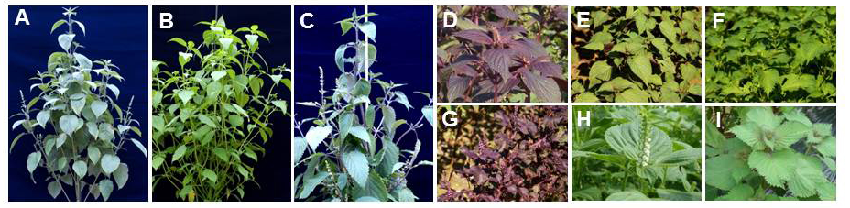
Supplementary Fig. S1. Photographs of the three wild and six cultivated Perilla species. (A–C) Wild Perilla species, P. citriodora (A), P. setoyensis (B), and P. hirtella (C). (D–I) Cultivated Perilla species, ‘Chajogi’ (D), ‘Apureunchajogi’ (E), ‘PureunJureumchajogi’ (F), ‘Jureumchajogi’ (G), ‘Deulkkae’ (H), and ‘Pureunchajogi’ (I).

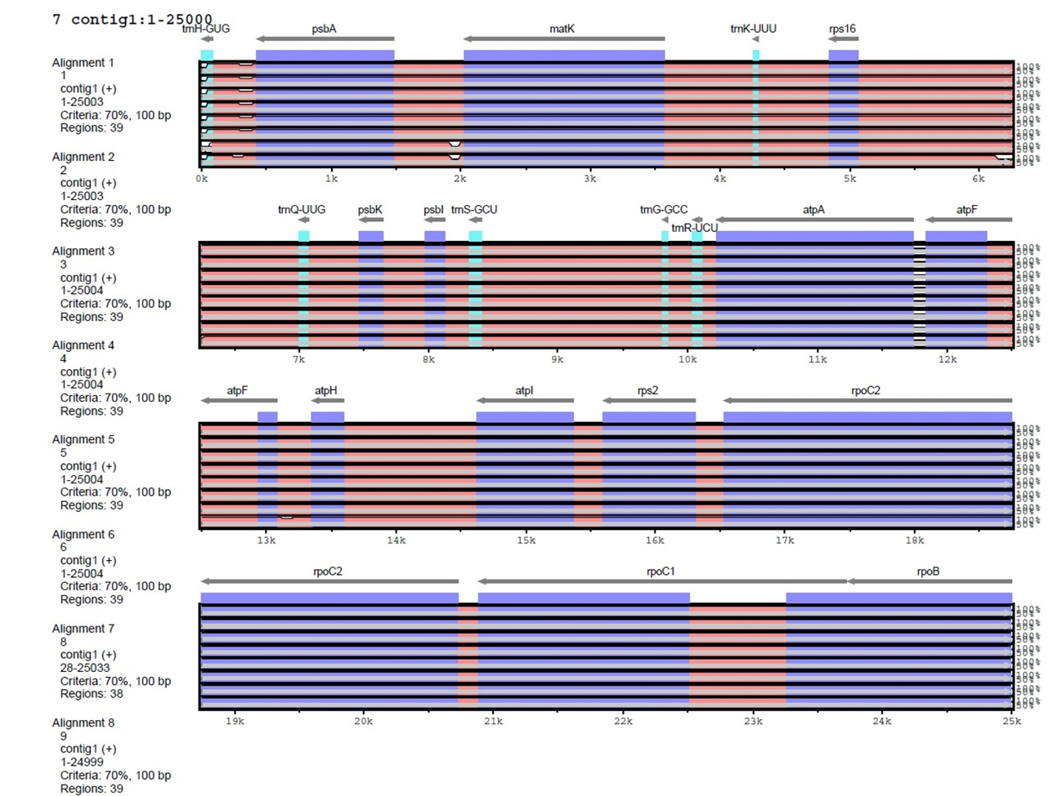
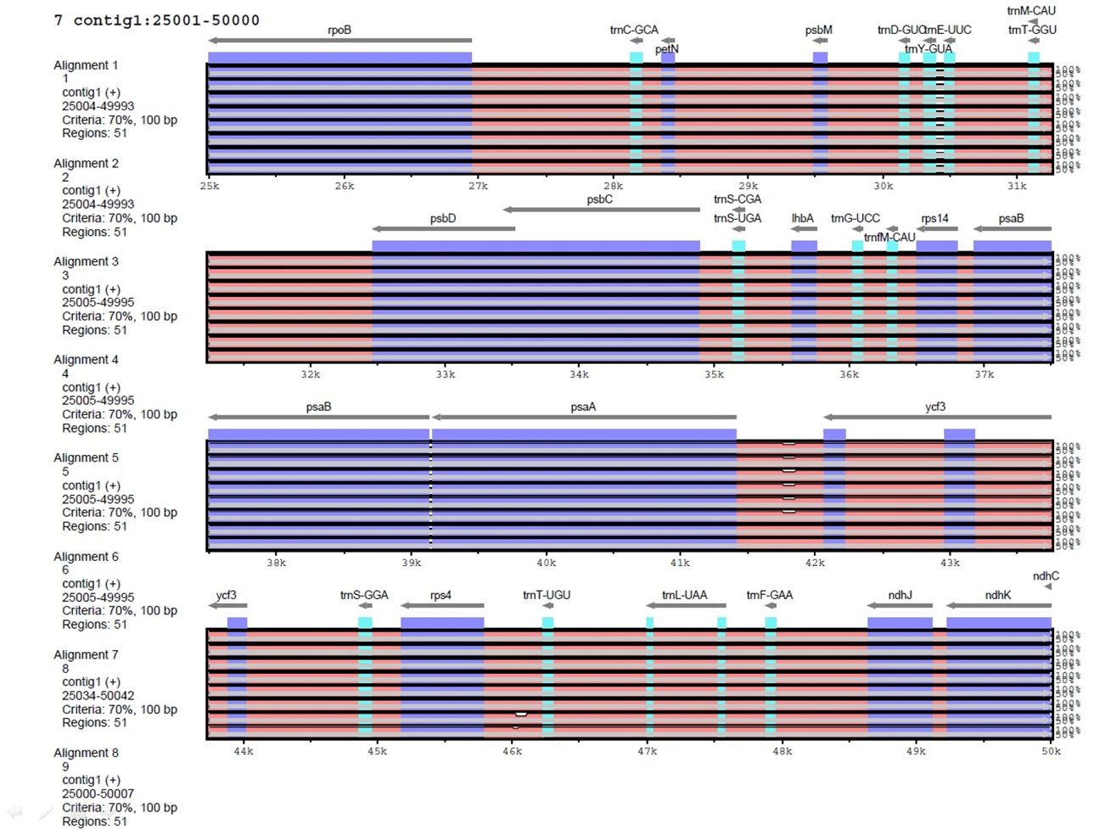
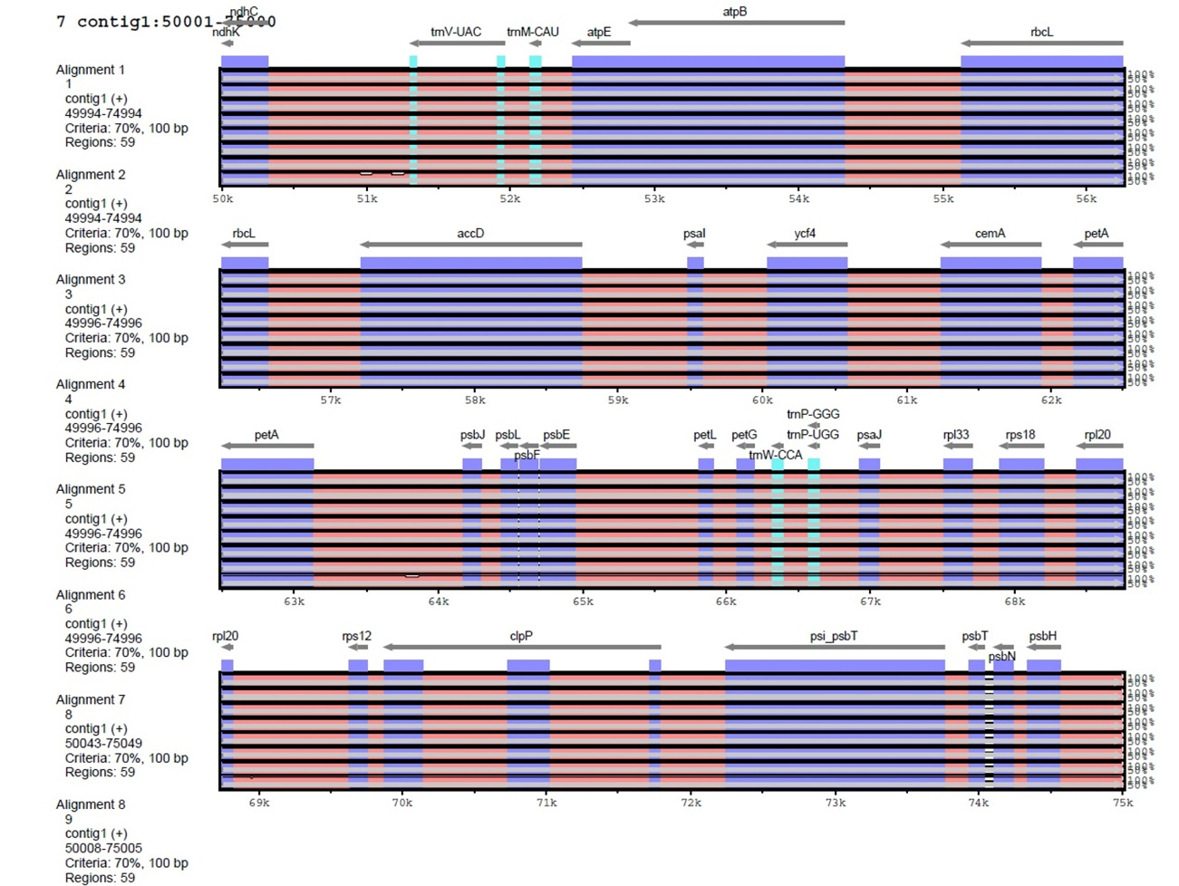
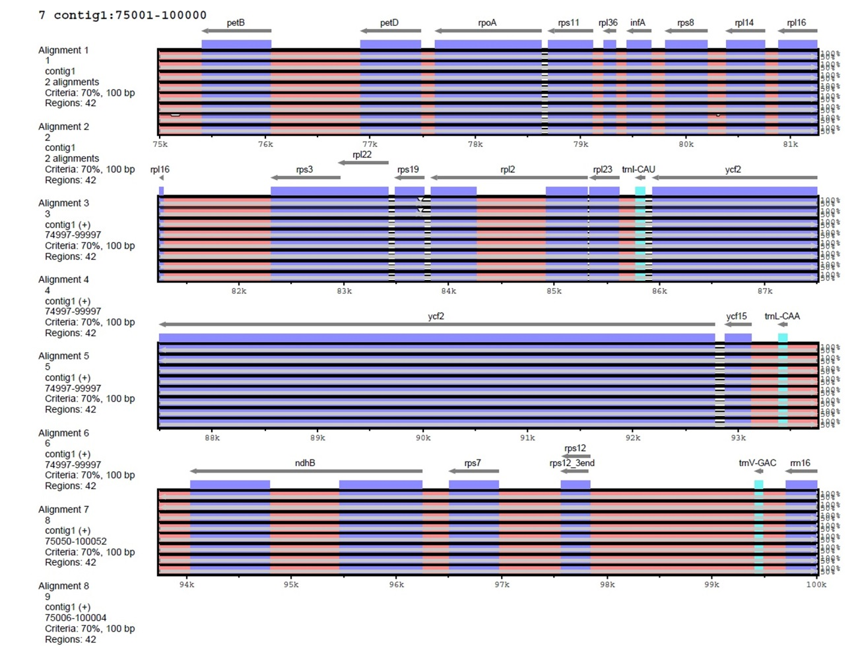
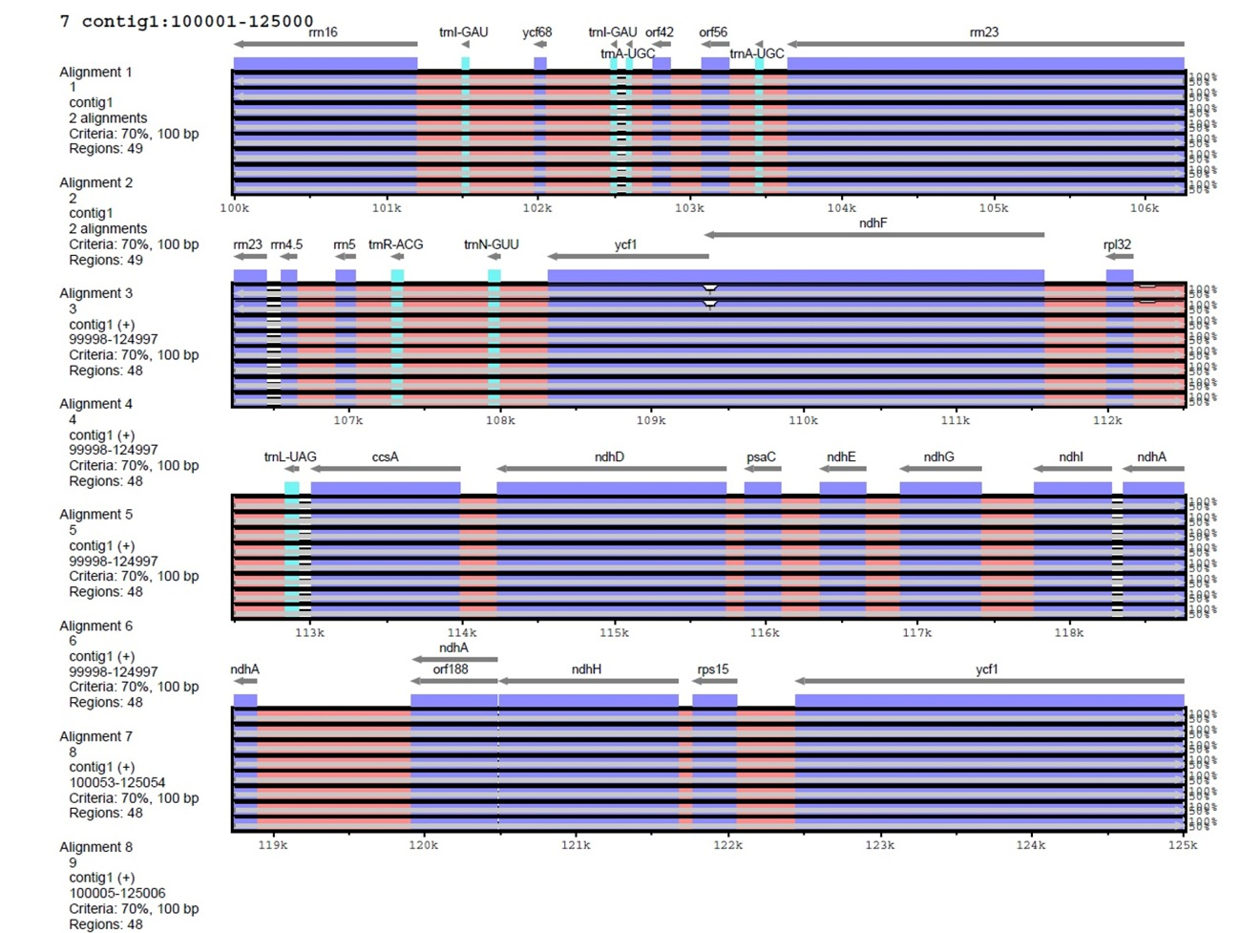
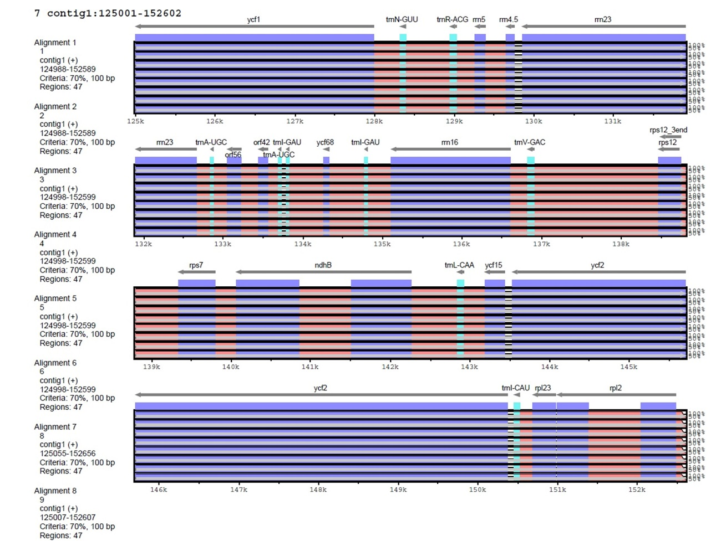
Supplementary Fig. S2. Comparison of the nine Perilla chloroplast genomes using the mVISTA program. The order of the nine Perilla species is as follows: P. citriodora, ‘Chajogi’, ‘Apureunchajogi’, ‘PureunJureumchajogi’, ‘Jueumchajogi’, ‘Dulkkae’, ‘Pureunchajogi’, P. setoyensis, and P. hirtella. Blue, conserved gene; turquoise, tRNA and rRNA; red, intergenic region; white, variation region.

