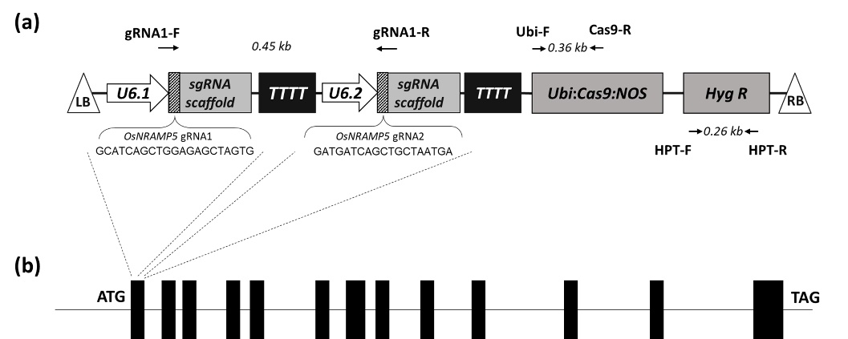
Supplementary Fig. 1. Schematic representation of the CRISPR/Cas9 T-DNA construct (a) and genomic structure of OsNRAMP5 (b). pCas9/sgRNA-OsNRAMP5 vector contains the Cas9 expression cassette driven by the ZmUbiquitin promoter (Ubi::Cas9::NOS), the hygromycin phosphotransferase (Hyg R) selection marker; two OsNRAMP5-targeting sgRNA expression cassette driven by two OsU6 promoters (U6.1 and U6.2). Arrows indicate primer positions for PCR analysis.

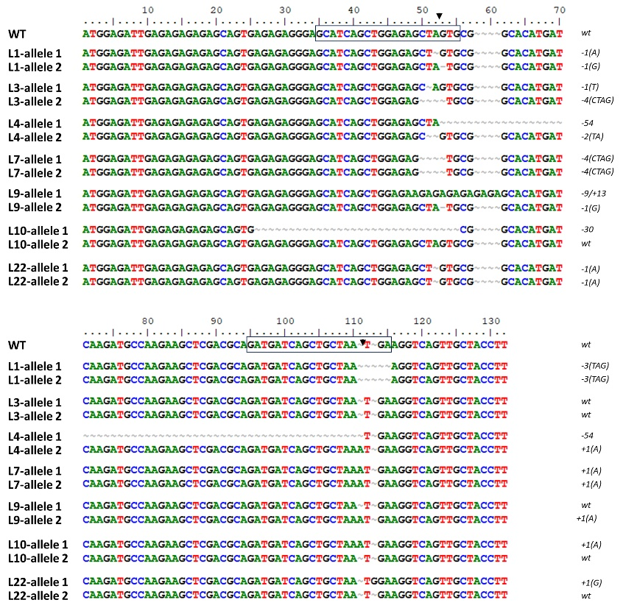
Supplementary Fig. 2. Alignment of OsNRAMP5 alleles in the target region. Boxes indicate gRNA target sites; arrows show predicted CRISPR/Cas9-induced DSBs. Left column: rice line names (WT: wild-type plant). Right column: genotype (+/- signs indicate nucleotide insertions/deletions; numbers show the count of modified nucleotides; capital letters represent altered nucleotides; wt: wild-type genotype).

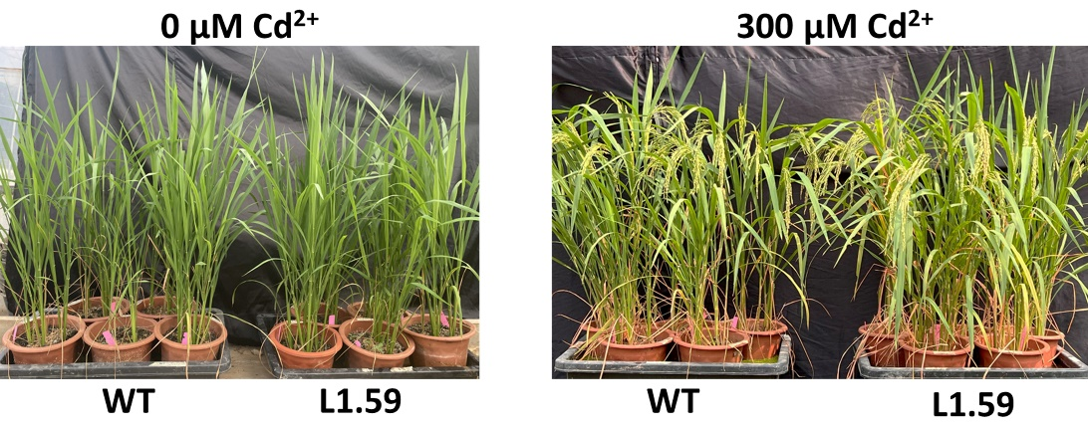
Supplementary Fig. 3. Morphology of wild-type (WT) and mutant (L1.59) TBR225 lines under treatment of 0 µM (left) and 300 µM (right) CdCl₂.

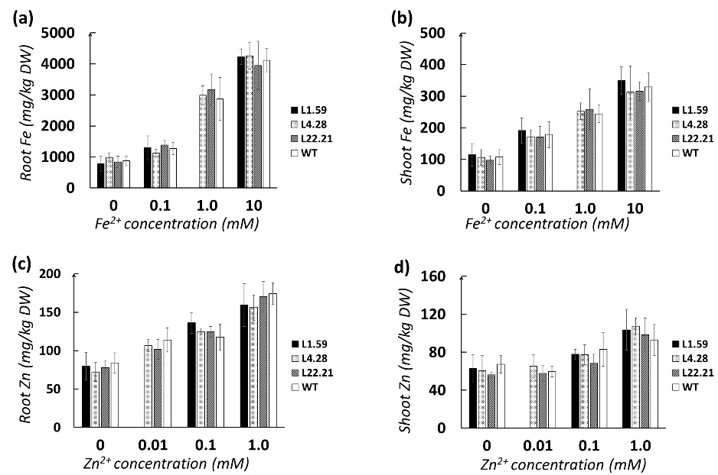
Supplementary Fig. 4. Metal accumulation in OsNRAMP5-edited TBR225 rice lines under different metal treatments. Plants were exposed to various metal concentrations for 2 months. (a, b) Fe concentrations in root (a) and shoot (b) after treatments with 0, 0.1, 1.0, and 10.0 mM FeCl₂. (c, d) Zn concentrations in root (c) and shoot (d) after treatments with 0, 0.01, 0.1, and 1.0 mM ZnCl₂. Bars represent mean ± SD from 3 biological replicates. WT: wild-type plant. Asterisks indicate significant differences compared to WT (Tukey's HSD test; P < 0.05).

Supplementary Table 1. Genotypes and seed production of T₀ OsNRAMP5-edited TBR225 lines.
No. | Name of T₀ line | Genotypeª | No. T₁ filled grain
1 | L1 | (-A/-TGA) || (-G/-TGA) | 121
2 | L3 | (-T/wt) || (-CTAG/wt) | 2
3 | L4 | (-TA/+A) || (-54) | 77
4 | L7 | (-CTAG/+A) || (-CTAG/+A) | 0
5 | L9 | (sub/wt) || (-G/+A) | 234
6 | L10 | (-30/+A) || ( wt/wt) | 48
7 | L22 | (-A/+G) || (-A/wt) | 115
ª(+/-) indicates nucleotide insertion/deletion; capital letters represent substituted nucleotides; (wt) denotes wild-type allele; (sub) indicates nucleotide substitution; numbers represent the length of insertion or deletion in base pairs; (||) separates the two alleles; (/) separates the two gRNA mutation sites.

Supplementary Table 2. Genotypes and seed production of T₁ OsNRAMP5-edited TBR225 lines.
Name of T₁ line | Genotypeª | No. of T₂ filled grain
L1.10 | -A/-TGA | 265
L1.38 | -A/-TGA | 65
L1.43 | -G/-TGA | 106
L1.53 | -G/-TGA | 68
L1.58 | -G/-TGA | 85
L1.59 | -G/-TGA | 415
L1.60 | -G/-TGA | 77
L4.28 | -54 | 108
L4.45 | -54 | 40
L9.32 | -G/+A | 24
L9.36 | sub/wt | 67
L22.3 | -A/+G | 17
L22.4 | -A/wt | 18
L22.10 | -A/wt | 28
L22.21 | -A/wt | 347
L22.49 | -A/wt | 65
L22.50 | -A/wt | 109
¹OsNRAMP5 mutation genotype; (+/-/sub) indicates insertion/deletion/substitution mutation; capital letters represent substituted nucleotides; (wt) denotes wild-type allele; (sub) indicates nucleotide substitution; numbers represent the length of insertion or deletion in base pairs

