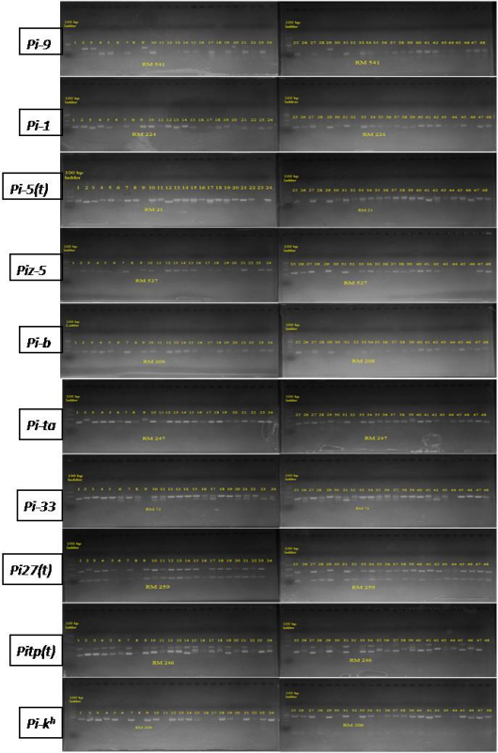
Supplementary Fig. 1. Agarose gel electrophoresis pattern of 48 rice germplasms using ten SSR markers (RM 541, RM 224, RM 21, RM 527, RM 208, RM 247, RM 72, RM 259, RM 246, RM 206). 1-48 stand for the name of different germplasm according to Table 1. Left side lane; 100 bp ladder was used to identify specific DNA fragment. Names of different markers were written on individual gel photograph.

