Plant Breed. Biotech. 2021 (September) 9(3):185~198  https://doi.org/10.9787/PBB.2021.9.3.185 | Online ISSN: 2287-9366  Print ISSN: 2287-9358

Microsatellite marker-based genetic diversity analysis and molecular screening for salinity tolerance among wheat accessions and cultivars of Bangladesh
Muhammad Shahidul Haque^{1*}, Nihar Ranjan Saha¹, Muhammad Abdul Hannan¹, Swapan Kumar Roy² and Sun-Hee Woo^{2*}
¹Department of Biotechnology, Bangladesh Agricultural University, Mymensingh 2202, Bangladesh
²Department of Crop Science, Chungbuk National University, Cheong-ju, Korea

* All the authors contributed to the work and manuscript preparation
Corresponding authors E-mail:
haquems@bau.edu.bd (M.S.H.); and shwoo@chungbuk.ac.kr (S.H.W.)
Address: Department of Biotechnology, Bangladesh Agricultural University
Mymensingh-2202, Bangladesh. Cell: +8801716066503

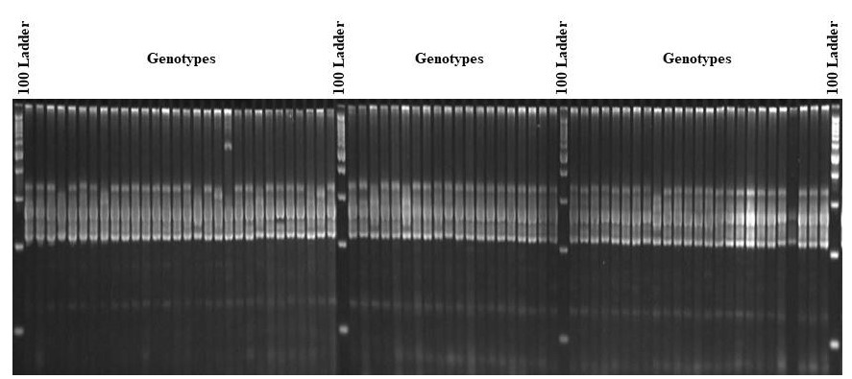
Fig. S1. Banding pattern of allele at the locus Xcfd-1 in 75 wheat genotypes.

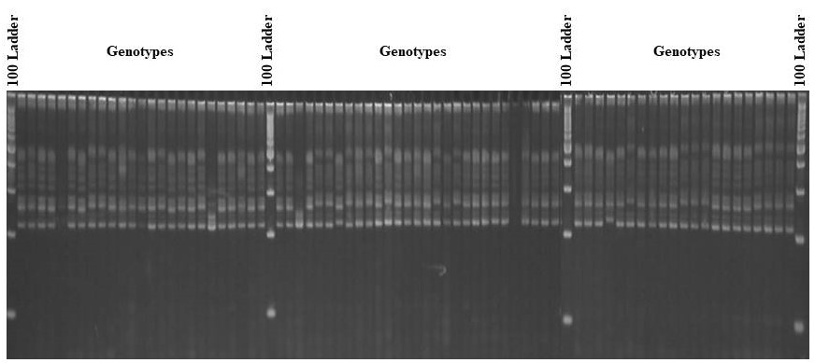

Fig. S2. Banding pattern of allele at the locus Xcfd-4 in 75 wheat genotypes.

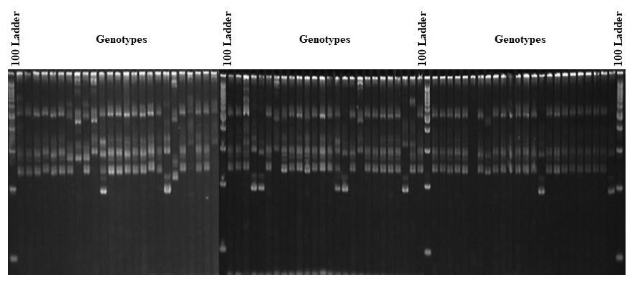
Fig. S3. Banding pattern of allele at the locus Xcfd- 13 in 75 wheat genotypes.

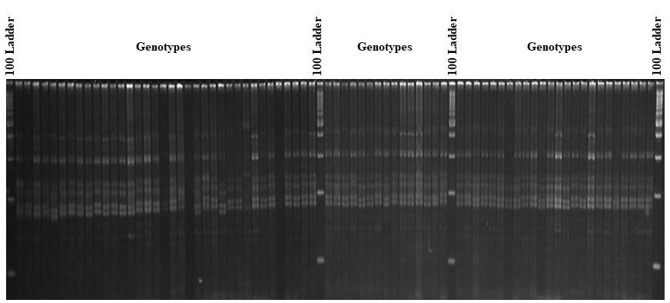

Fig. S4. Banding pattern of allele at the locus Xcfd- 46 in 75 wheat genotypes.

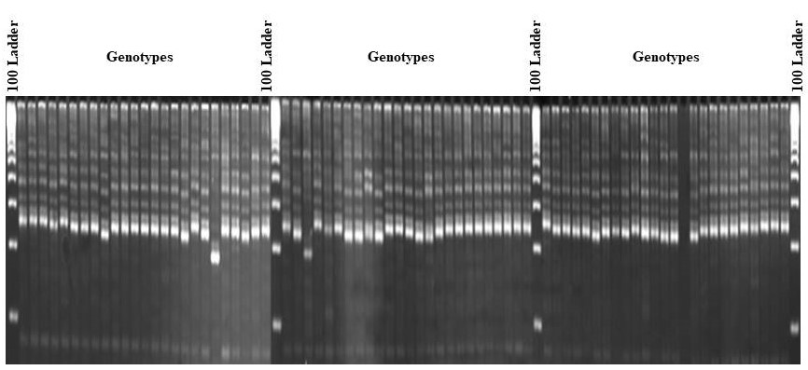

Fig. S5. Banding pattern of allele at the locus Xcfd- 54 in 75 wheat genotypes.

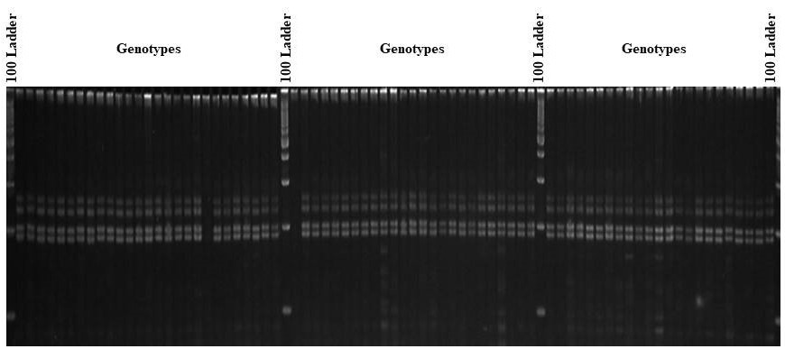

Fig. S6. Banding pattern of allele at the locus Xcfd- 183 in 75 wheat genotypes.

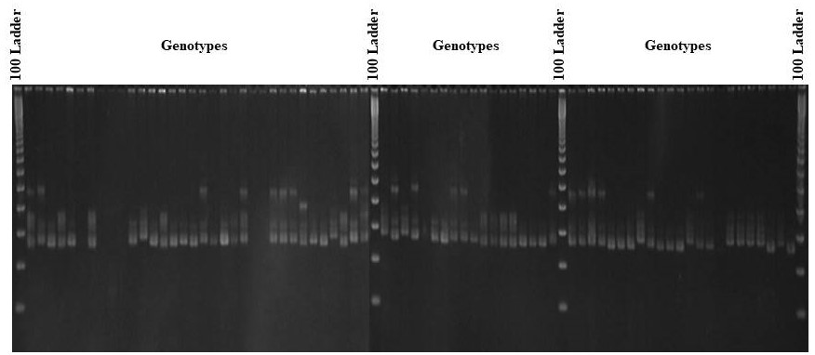

Fig. S7. Banding pattern of allele at the locus Xwmc- 11 in 75 wheat genotypes.

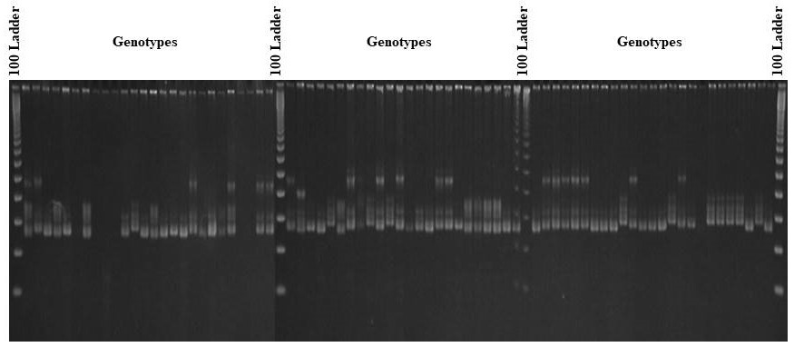

Fig. S8. Banding pattern of allele at the locus Xwmc- 18 in 75 wheat genotypes.

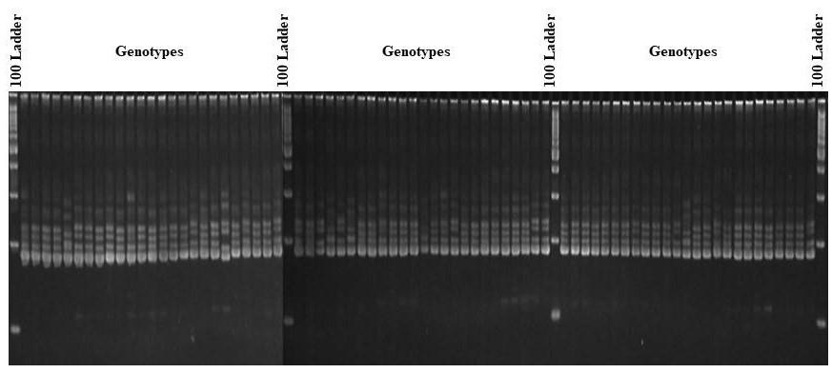

Fig. S9. Banding pattern of allele at the locus Xwmc- 96 in 75 wheat genotypes.

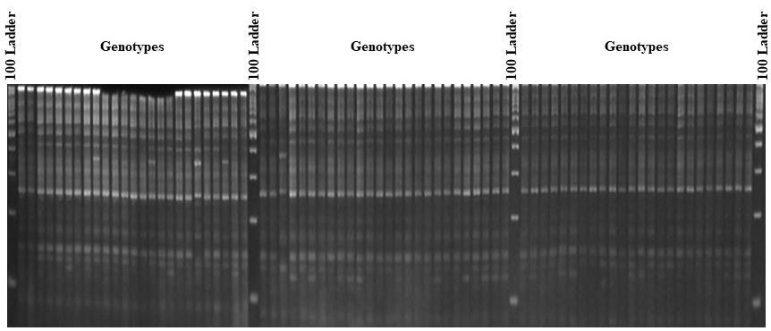

Fig. S10. Banding pattern of allele at the locus Xwmc- 110 in 75 wheat genotypes.

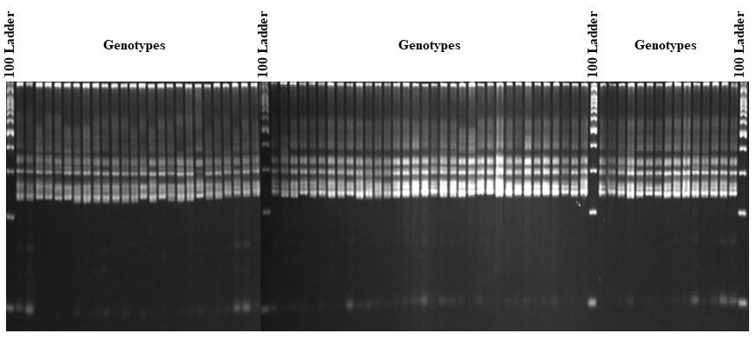

Fig. S11. Banding pattern of allele at the locus Xwmc- 154 in 75 wheat genotypes.

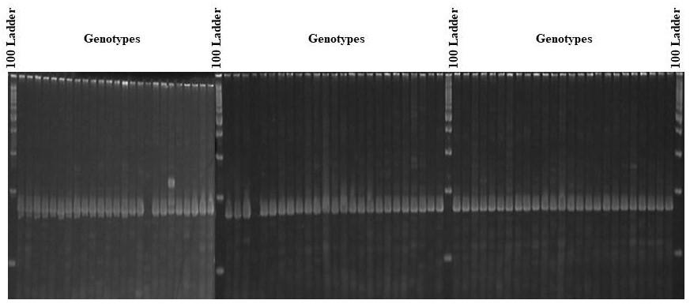

Fig. S12. Banding pattern of allele at the locus Xwmc- 405 in 75 wheat genotypes.

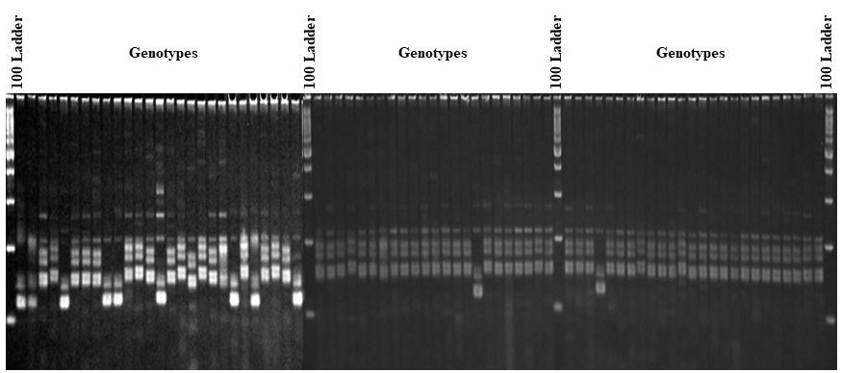

Fig. S13. Banding pattern of allele at the locus Xwmc- 406 in 75 wheat genotypes.

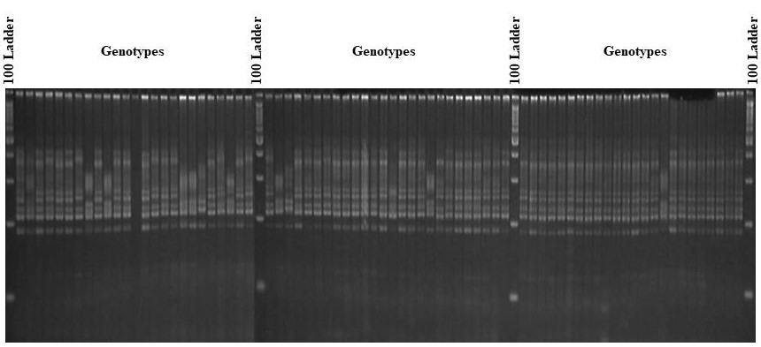

Fig. S14. Banding pattern of allele at the locus Xwmc- 503 in 75 wheat genotypes.

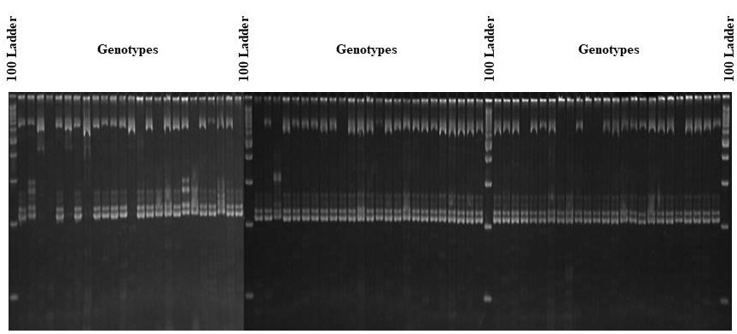

Fig. S15. Banding pattern of allele at the locus Xgwm-160 in 75 wheat genotypes.

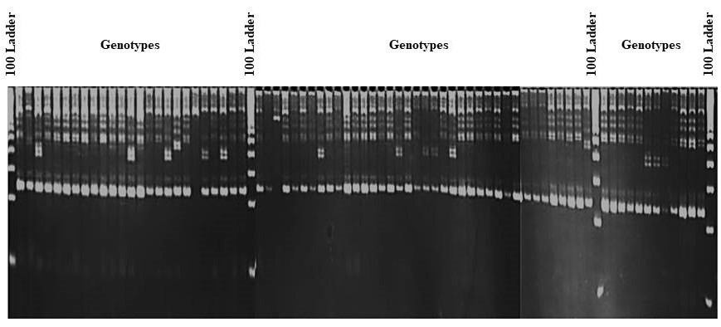

Fig. S16. Banding pattern of allele at the locus Xgwm-493 in 75 wheat genotypes.

